Usability Evaluation: Campus Events App.

lis 9607 w/xiao

Due: April 8th, 2014

Mark Borden ([mborden@uwo.ca](mailto:mborden@uwo.ca))

Contents

Overview 1

Procedure 2

Results 4

Interpretation 6

Appendix A - Information Letter & Consent Form 11

Appendix B - User Background Survey 13

Appendix C - User Reaction Survey 15

Bibliography 17

# Overview

In order to uncover usability issues with our Campus Events mobile application design, we conducted a Usability Evaluation.

**Formative Evaluation**

Relying on a cooperative evaluation/think aloud methodology, our formative evaluation involved four participants; each participant completed a background survey, then engaged in four situational "think aloud" activities involving our prototype. Participants then completed a user reaction survey in light of the "think aloud" activity. This evaluation allowed us to observe what aspects of our design posed challenges to users. User "errors" were noted and the data was used in our redesign process.

**Re-designed Prototype** In light of our formative evaluation, we made the following altered or added the following features to our previous prototype:

* A wheel containing event categories with subcategories listed on the side
* Clear distinguishable date headers
* Event information is clearly laid out in segmented spaces
* Option to 'add to calendar'

Images of the changes and redesigned application design are included in the Interpretation section of this report beginning on page 6.

# Procedure

Our usability evaluation consisted of two questionnaires and a cooperative evaluation of our prototype. Both of our questionnaires were comprised of scalar and open-ended questions. Our first questionnaire was a “User Background Survey” (see Appendix B) which we administered prior to conducting the cooperative evaluation. The intended purpose of this questionnaire was to gather data on participant’s familiarity with both the current iWestern app and with mobile technology in general. The “User Reaction Survey” (see Appendix C) was administered after the participant completed the cooperative evaluation. This questionnaire was adapted from one found in *Usability Engineering* (Rossen & Carroll, 2002) and was designed to elicit user views which we were hopeful would give us some data we can use to inform redesign decisions.

Originally our group was contemplating using the “think aloud” method but, after we quasi-pilot tested the prototype by amongst ourselves, we came to the collective decision that a cooperative evaluation would be more appropriate given that our prototype was limited in functionality. Our concern was that because the prototype looks so much like a functional app, participants may think that they would be able to navigate through in its entirety. Our choice to use cooperative evaluation, rather than a pure think-aloud evaluation, helped inform our assistance policy. Our group agreed to interject if the participant began to deviate into parts of the prototype which were not built. Our group also agreed that we would assist the participant if they were able to verbalize what they wanted to do but were unable to locate the option or method to do so. For example we had a participant who informed us that he/she wanted to access the calendar but were unable to locate it on the screen. There is an icon to accomplish that task; however, the participant did not recognize it as being representative of a calendar.

Procedurally, the cooperative evaluation was accomplished by having participants complete four different task-oriented scenarios on our low-fidelity prototype and describe what they were doing and why. The research team chose to have the participant interact with the prototype on an iPad to emulate using it on a mobile device. There was open dialog between the evaluator and the participant during this process where both were free to ask questions to the other. The tasks participants were asked to complete are as follows

1. You are an undergraduate student struggling with taking multiple choice test. Someone has told you about "test preparation workshops." You are generally free on Thursdays. How might you go about finding one of these workshops?
2. You are a philosophy student who is planning on going to an event that pertains to your discipline on March 12 (today). You told your friend you would email him/her the event information. How would you find the event information that your friend wants?
3. You are planning on going to the event "Gisela and her bathtub lovers". You want to share the event information with your friends, and check the event location. How do you go about this?
4. You are an undergraduate student struggling with taking multiple choice test. Someone has told you about "test preparation workshops." You are generally free on Thursdays. Please navigate to this event through "calendar" mode, as opposed to "wheel" mode.

These tasks were designed to test the findability and usability of several of the apps features. Success was measured by whether or not the participant was able to complete their assigned task. Fortunately all participants were able to complete their tasks suggesting that there are no readily apparent major design issues.

During the cooperative evaluation a member of our design team recorded what the participants said, while another made note of user errors. After completing the second questionnaire, the session "evaluator" asked made inquiries of the participant asking for feedback or about specific errors made during the evaluation.

Four participants participated in the usability evaluation of our prototype. Two participants were asked to complete the task in the order 1234, while the other two participants were asked to complete the task in the order 2314. Participants included a classmate, a FIMS student and two individuals peripherally associated with Western. Great care was taken to assure testing conditions were similar for all participants.

# Results

## User Profile & Expectations

By administering a user background survey we were able to gather some data about participants which will help in analyzing how representative our testing was as well as identify user expectations and searching habits.

Figure 1 illustrates the make-up of our sample regarding academic status. Because we aim to produce an app that all students as well as alumni will be able to use, it was important that we have a range of academic statuses represented in our user testing. We were able to have at least one person from each group participate.

**Fig. 1**

|  |  |  |  |
| --- | --- | --- | --- |
|  | Undergraduate | Graduate | Alumni |
| Status | I | II | I |

Figure 2 illustrates the users’ personal telephone use. As the chart demonstrates, we gathered only Android and Blackberry users. While the app is developed for use on many platforms, we based our prototype on the iPhone as our initial studies suggested that a majority of students prefer that model. Further testing may be necessary in order to include feedback from iPhone users. 🡨 Tracy said on March 10, 2014: We use Flurry to track usage, so are able to provide you with some stats:

Total unique users:

iOS = 19,726

Android = 3,973

BlackBerry = 584

# sessions over the last month:

iOS = 10000

Android = 3500

BlackBerry = 130

**Fig. 2**

|  |  |  |  |
| --- | --- | --- | --- |
|  | iPhone | Android | Blackberry |
| Phone Type |  | II | II |

Figure 3 is an illustration of one of our survey questions. Because a significant majority of users answered this question in the same manner we can make some predictions about how most users will interact with the app. As the majority of users report searching for specific events, it will be important that our search feature in particular is user friendly. Similarly, our browsing tools must be precise enough to help users find the event they are looking for. Based upon the data presented in Figure 3, we assume that fewer people will be using the app to merely browse through events. However, a larger sample is necessary to make conclusive predictions.

**Fig. 3**

3 out of 4 users said this statement best describes them:

* I hear about event then seek out information about them in order to attend.

Our final survey question asked about what features users would expect to find in a campus events app. Figure 4 demonstrates that there is a fairly clear consensus on what users think is important in this type of interface.

**Fig. 4**

With this information, we have gained insight into how users seek information about campus events as well as what information they seek in order to attend.

## User Errors

For the usability testing we wanted to focus on certain features. As we had participants walk through tasks, we sometimes had to redirect them to use the feature we wanted to explore, even though the path they chose would also have allowed them to complete the task. As a result, the time it took to complete tasks varied depending on which method the user chose to complete the task and how many times they had to be redirected. Therefore, we decided to forego using time as a measure of success, and instead focused on user errors or problems. Below are our error results and discussion.

|  |  |  |  |  |  |
| --- | --- | --- | --- | --- | --- |
| User | Screen #1 | Screen #2 | Screen #3 | Screen #4 | Screen #5 |
| User #1 |  |  |  |  | III |
| User #2 | II |  |  | I |  |
| User #3 | I |  |  |  | I |
| User #4 | II |  |  |  |  |

**Fig. 5**

**Fig. 6**

As is evident from the above chart, the majority of errors occurred in the first (home) screen and the fifth (event page) screen. These screens have features that are not clear to users.

**Screen #1 Errors:**

The errors in the home screen were connected with three users failing to recognize the changing subcategories which appear along the right hand side of the screen and change as the wheel is turned. After selecting the wheel category, going on to choose from among the subcategories was not an obvious next move for them. They expected a new screen to appear after selecting a wheel category.

The other errors on the first screen are reflective of the difficulty two users had in recognizing the calendar icon. They reported it looking like a typewriter or a garbage can.

**Screen # 4 Errors:**

One error took place on the fourth (event listing) screen. The user thought that it was the final screen and expected to find all event info there, as well as sharing functionality.

**Screen #5 Errors:**

The most problematic screen for users was the final (event page) screen. All errors took place around the share/RSVP section. One user was unfamiliar with the “add to calendar” feature and was confused by its presence beside the Facebook, email and twitter options. The same user was also confused by how closely located the RSVP feature was to the share feature. The user thought that you had to RSVP by using one of the share features. This became more confusing when on another task the RSVP said “you don’t need to RSVP to this event.”

User # 3 was also confused by the RSVP feature. The user reported thinking that they would expect that feature to read “sign up here”.

## Think-Aloud Data

A review of the "think-aloud" data revealed two main areas of confusion with the interface. The calendar icon and the RSVP function.

**Calendar Icon Confusion:**

Two users were particularly confused about the calendar icon on the main (pinwheel) page.

User #2: “What is that typewriter thing? Oh it’s not? Oh it’s a calendar.”

User #4: “I didn’t click the calendar because I thought it was the Windows garbage can.”

Both users’ confusion was related to the appearance of the icon. This is something that should be fairly easily remedied in the re-design.

**RSVP Confusion:**

Two users were confused with the RSVP section of the events page.

User #1 was particularly confused by its proximity to the share features. The user assumed that because they were so close, you must have to RSVP through one of those features. In actuality, the RSVP would link the user to the registration website and is therefore not connected with the share features. This was especially confusing when the note read “RSVP not necessary for this event” as the share features remained in place.

User # 3 reported feeling that RSVP was confusing terminology. They would expect to see “Sign-up here” instead.

Both the wording and the placing of the RSVP feature led to user problems.

## User Reaction Survey Results

Figure 7 shows a visual representation of the Likert scale questions that users answered in the user reaction survey. In this chart , "1" represents a strong negative and "4" represents a strong positive. The results indicate that users had the most issues with the “wheel” vs. “calendar” mode. Also, users tend to prefer the calendar view to the wheel.

**Fig. 7**

The written responses to the survey reflect the likert scale questions. Three out of four prefer the calendar view. With two users reporting that the pinwheel felt confusing.

One of the main problems with this user test was the lack of functionality for the wheel. While users reported finding it confusing, it is difficult to gauge how and if that would change if the wheel responded to their manipulations. Before moving away from the wheel design, it may be necessary to test it with full functionality. However, the responses demonstrate that clarity about finding the calendar as opposed to the wheel is necessary.

# Interpretation

In light of our findings from our usability evaluations, we have made five alterations to our proposed Campus Events mobile application design.

## 1. A clearer calendar icon in the top left corner

As our users indicated, both through their survey responses and through their errors during the evaluation process, that the possibility of switching from “wheel”-mode to “calendar”-mode was not particularly evident to them we altered the calendar icon. The calendar icon was assumed to be a trash can by one participant, and an image of a typewriter by another. As the wheel to calendar-mode switch opens the possibility for the user to browse events in an entirely different way (by date instead of by category) this confusion must be overcome. Do to time restraints, replacing the calendar icon with a clearer icon is a good solution. The small size of the icon makes the image difficult to decipher; thus, we have altered it to a numeric icon style which may be a more intuitive image given the size constraints. This does not overcome the user’s initial lack of awareness that there is an alternative to the “wheel-mode", but it should make the alternative easier to discover.

|  |
| --- |
| A clearer calendar icon in the top left corner |
| + clarifies "calendar" for users |
| + involves minimal changes to the proposed design |
| – still involves exploration to fully understand feature |

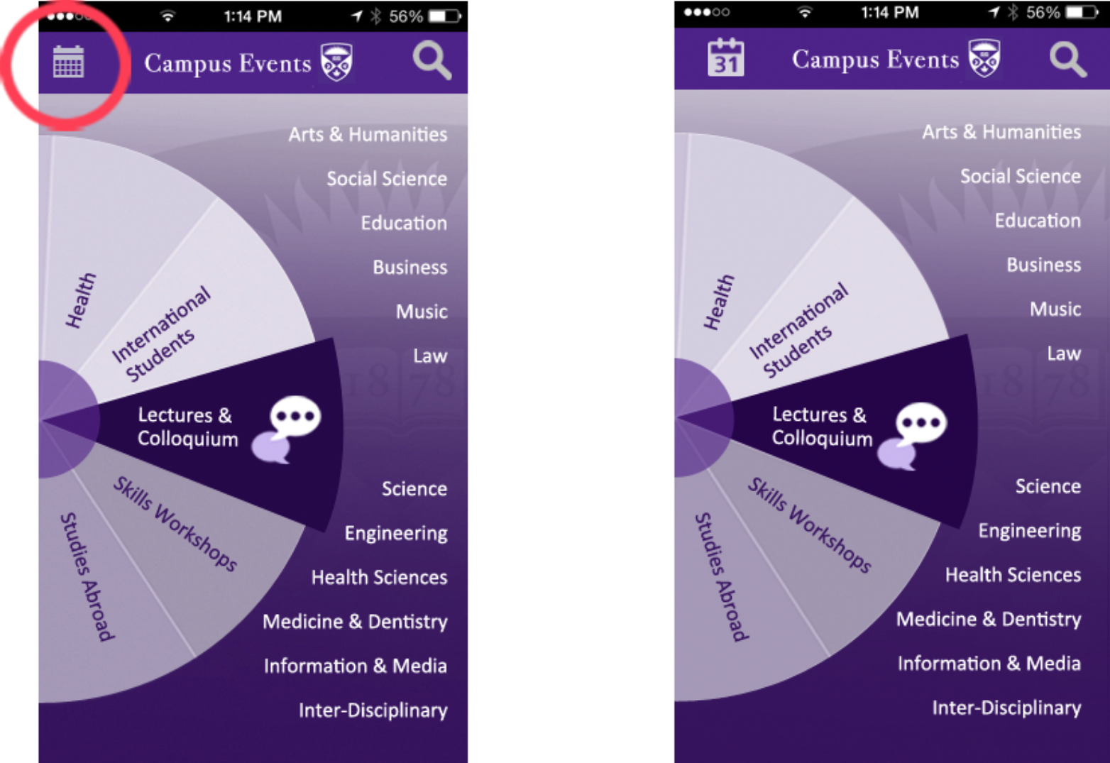

## 2. Sharing capabilities on the event listings screen

As no users remarked upon the star/highlight feature on the listed events screen (indicating that either the feature held no value for them or that they did not recognize or understand it), but were generally pleasantly surprised that they could share the event on the following screen, we have opted to exchange the star feature for a sharing feature. This is not an imperative change; users could still accomplish the task of sharing by proceeding to the 'full-view of the event' screen; however this change seems to reflect better the needs of users and is easily done from our design perspective.

|  |
| --- |
| Sharing capabilities on the event listings screen |
| + more relevant to users expressed wants/needs (users seem to value sharing capabilities more than star/highlighting capabilities) |
| + fewer steps are required for those who do not wish to see the event details but merely wish to share the event |
| + makes good use of space |
| - users may not view the 'full-view of the event' screen, thereby missing certain event details, if they are not obligated to view the full event screen to share |

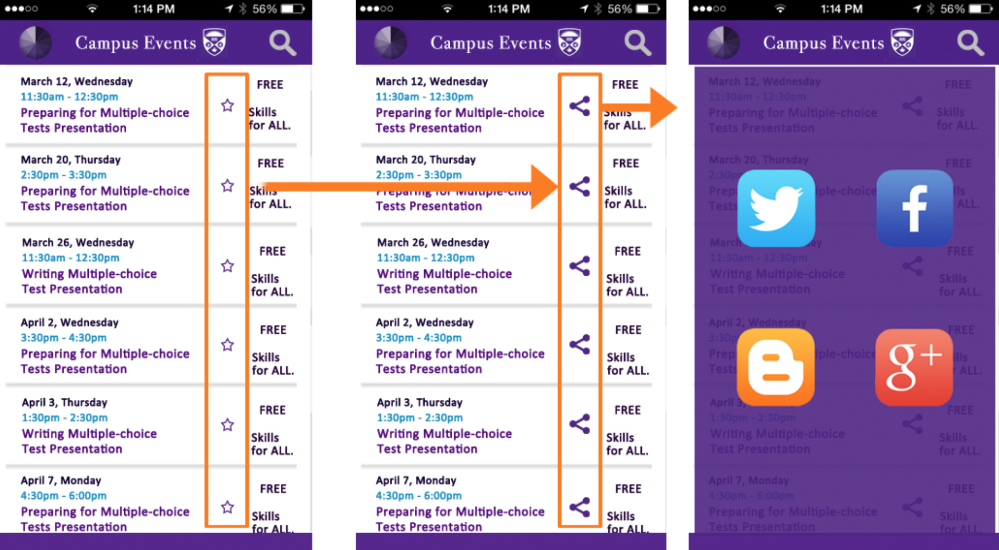

## 3. Differentiating the RSVP section from sharing capabilities

The proximity of the “RSVP” section to the email, social media sharing, and add to calendar buttons caused a few of our participants to conflate RSVP and registration information with RSVPing via Facebook or email. As it is crucial that users are able to properly recognize how to RSVP for events that require confirmation or registration, resolving this issue is of high importance. We have segregated the RSVP information from the share icons to clarify the matter for users. Besides this we have chosen to exchange the terms "RSVP" or "No RSVP" with the terms “Sign up” and “No registration required”, respectively.

|  |
| --- |
| Differentiating the RSVP section from sharing capabilities |
| + clarifies/distinguishes sharing capabilities from modes of RSVPing |
| + relies upon more natural language |
| + requires minimal effort to design team to make slight alteration in wording |

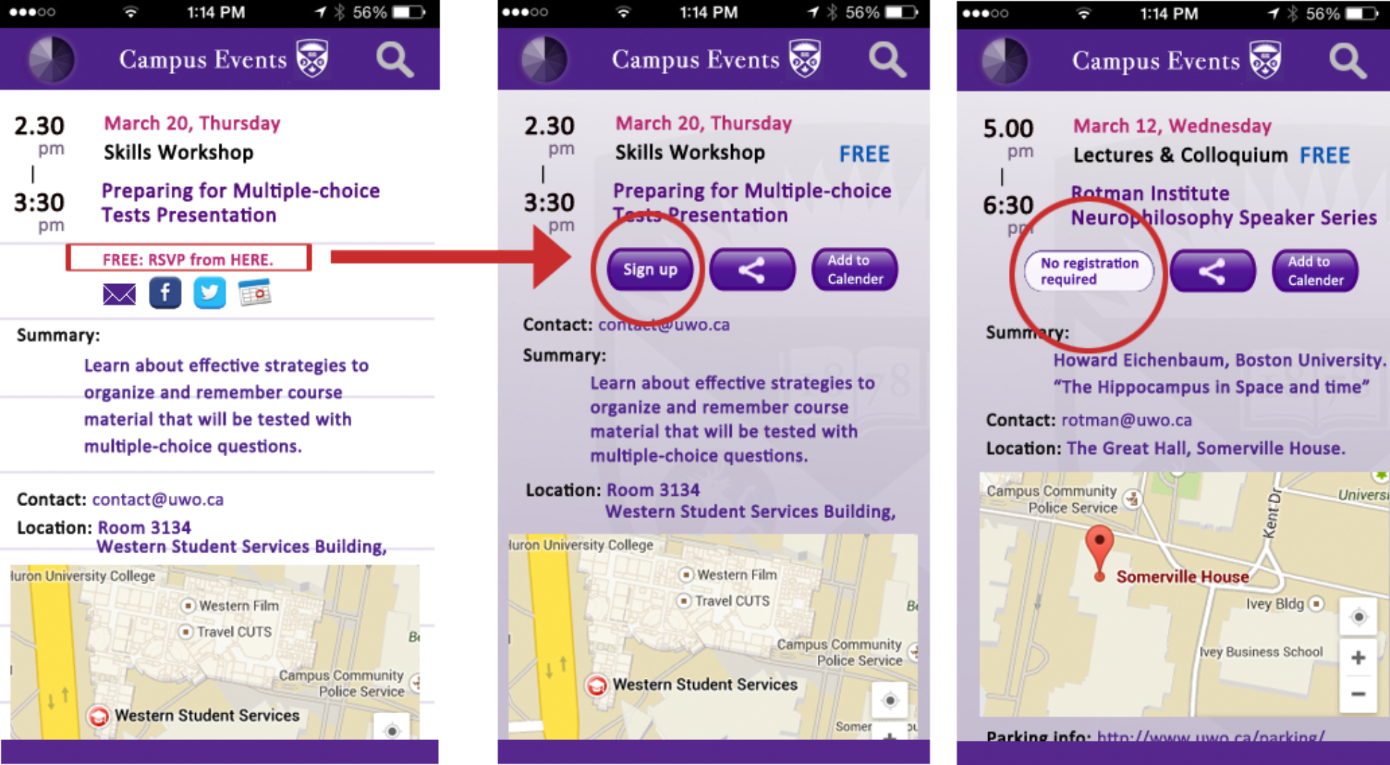

## 4. Single Share icon instead of email & social media icons; clearer ‘Add to calendar’ icon

As users indicated some confusion around the provision of the email, social media, and add to calendar icons, and as event facilitators may wish to include links to their event's Facebook or Twitter pages on the event screen, we have opted to streamline these features. A single share icon will replace the email, Facebook and Twitter icons. Tapping the share icon will present users with the options of media integrated into their phone that they can share the event through. An add to calendar icon will remain, but be altered to offer greater clarification.

|  |
| --- |
| Clarifying the email, share, and add to calendar features |
| + streamlines the share/email/add to calendar capabilities with recognizable standard icons |
| + avoids confusion of sharing the event through user’s social media and viewing the event on social media. |
| + provides back-end stakeholders with the option of providing links to their event’s social media pages using social media icons |
| + single icon (instead of several) lessens the fat finger problem |
| * - involves an extra step of selecting which social media you want to share through |

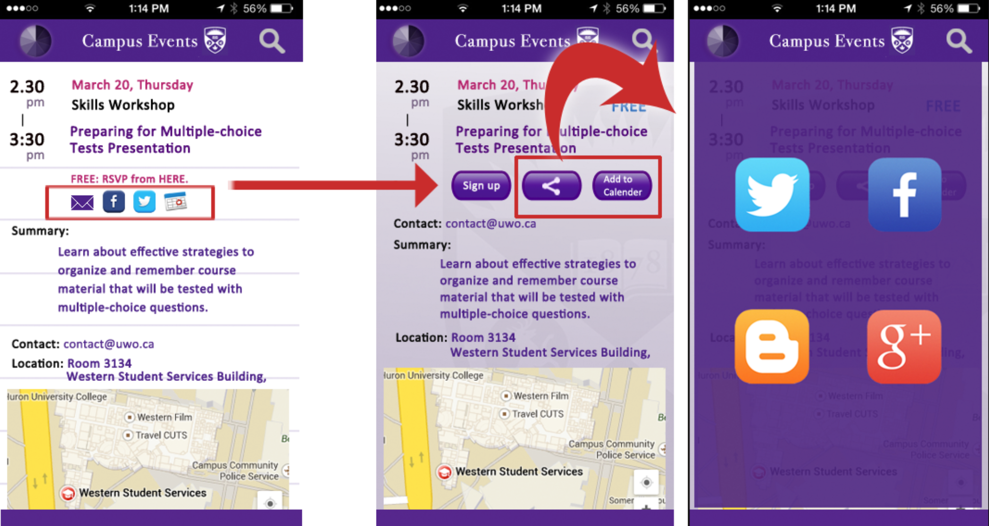

## 5. Making the "wheel” the Primary mode

One issue not addressed by our usability evaluation participants, but which we, as a design team, had not fully addressed was the impractically and, at times, superfluous nature of a strict wheel-calendar dichotomy. When users are viewing an event listings screen, for example, they are in neither wheel-mode or calendar-mode, so what icon do we display in the top left corner? Having recognized the impracticality of a full wheel-calendar mode dichotomy, we have selected the "wheel" as the "home", or primary search/browse mode. Thus, the wheel icon will be present in the top left corner on all screens expect the "home" wheel screen where the calendar icon will be present.

|  |
| --- |
| Making the "wheel" the primary mode |
| + respects the common browsing habits of event attendees |
| + addresses an oversight on the part of the design team |
| + provides a primary search/browse mode for users |
| – involves more steps for users who prefer to search/browse in "calendar-mode" |

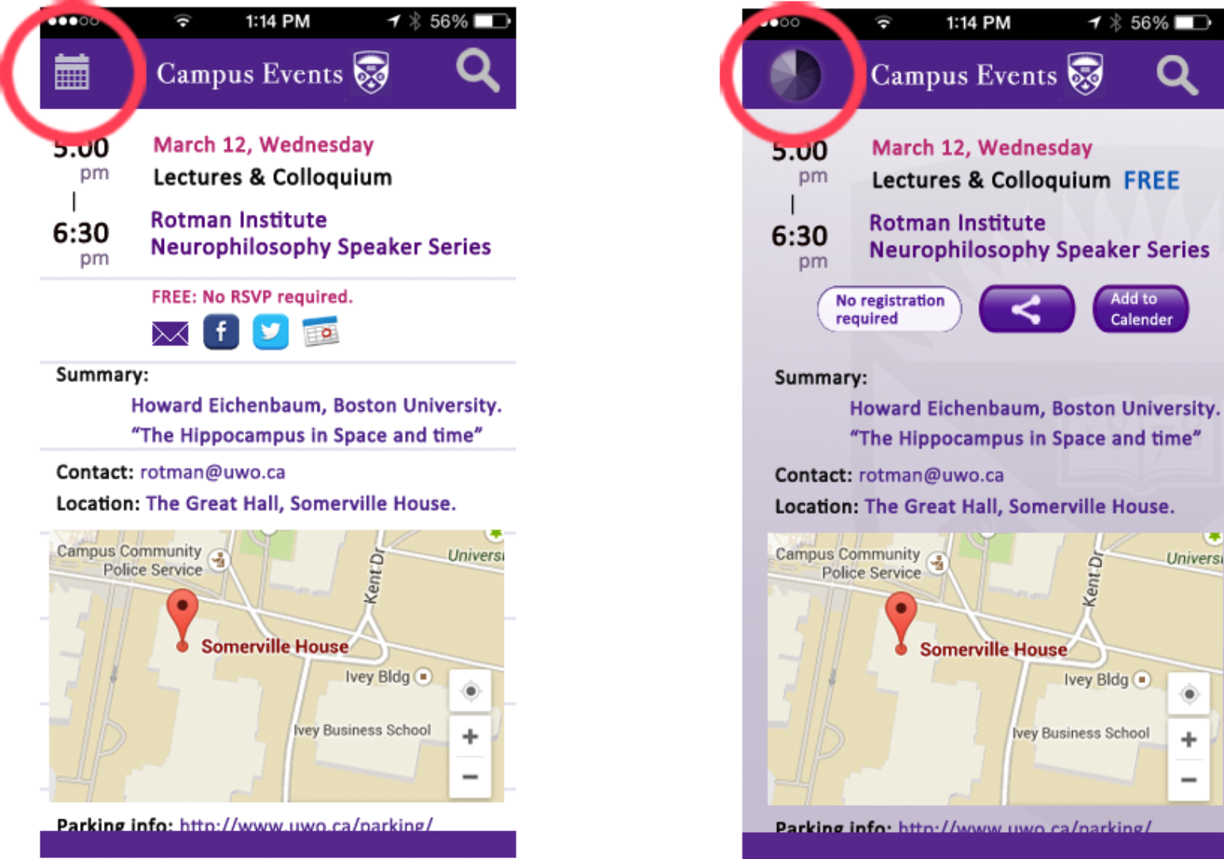

## Changes we did not make

That subcategories accompany the main categories on the wheel and that they are the portal through which events are accessed was not evident to all participants of our usability evaluation. Some assumed that by tapping on the wheel’s categories a new page listing the chosen category’s events would load. This is an important issue as it pertains to the primary mode of searching in our proposed design. Our team, however, is convinced that this perceived problem lies not in the design itself, but in our prototype’s underdevelopment. With full functionality, we are convinced that as users would inevitably notice the altering subcategories as they spin the wheel and recognize them as the means by which to direct oneself to the next screen. Certainly, this assumption bears further scrutiny, but at this time we are not convinced it is a design worth re-conceiving.

## Developments still to be addressed

While our previous card sorting analysis somewhat informs the categorization of events further work remains to be done before official categories and subcategories are adopted for a Campus Events app.

# Appendix A - Information Letter & Consent Form

#### Campus Event Mobile App Usability Evaluation Study

We are students in the Faculty of Information and Media at The University of Western Ontario and the information we are collecting will be used in a research project for one of our classes, LIS 9706: User Experience.

#### INVITATION

You are being invited to participate in a research project regarding user experience and mobile application design. We have designed a prototype for a Campus Events app and are seeking potential users to evaluate and provide feedback on our design.

#### WHAT PARTICIPATION ENTAILS

If you agree to take part in this study, you will be asked to complete a brief background survey providing us with information about your familiarity with mobile apps in general and event/calendar apps in particular. You will then begin the formal usability evaluation; this will involve being shown a series of mock-up images of a proposed Campus Events mobile application and being given a series of “tasks”/instructions that you will then have to talk through. The process is not a test, but a means of evaluating design problems for the proposed app design. A member from our team will interact with you through the process providing you with new mock-up images and new instructions. You will be encouraged to “talk out” problems instead of seeking answers from your guide. Following the completion of these tasks you will be asked to complete a brief evaluation survey, and may then be asked some informal questions about your experience and given the opportunity to offer additional feedback. This process will take approximately 20 minutes.

#### RISKS

There are no known risks to your participation in this study.

#### VOLUNTARY PARTICIPATION

Participation in this study is voluntary. You may refuse to participate, refuse to answer any questions or withdraw from the study at any time with no effect on your academic status. This project is an opportunity to give students experience in doing research, it is a training and teaching exercise. Please note that if you decide not to participate or to withdraw from the study at any time, my grade in the course will not be affected.

#### CONFIDENTIALITY

Information collected during the course of this study will remain in the care of our design team who intend to keep it secure, and the data will be destroyed at the end of the term.

The results of the project will not be published, but the data collected will be discussed during my classes, and contribute to our final report. However, the class members will not know who you are because once all the data have been collected, your name and any identifying information will be removed from the data to protect your confidentiality.

#### CONTACTS

If you have any questions about the study, you may contact any of us:

Mark Borden at mborden@uwo.ca,

If you have questions about your rights as a research subject you may contact the Director of the Office of Research Ethics, The University of Western Ontario at *519-661-3036 or ethics@uwo.ca.*

#### CONSENT FORM

I have read the Letter of Information, have had the nature of the study explained to me and I agree to participate. All questions have been answered to my satisfaction.

Date:

Signature of Research Participant:

Name of Participant (Printed):

Signature of Person Obtaining Consent:

Name of Person Obtaining Consent (Printed):

# Appendix B - User Background Survey

Participant Background Survey

Thank you for agreeing to participate in this Campus Events App Usability Evaluation. The nature of the study has already been explained to you in the Information Letter. Before we have you evaluate our app in its current prototype form we require some general background information from you. This information will give us a sense of your current interactions and familiarity with apps such as ours.

1. Do you have a Smartphone?

* Yes
* No
  1. If yes, what kind of Smartphone do you use?
* IPhone 5
* Other IPhone
* Android
* Blackberry
* Other (please specify) ___________________

1. Do you use the calendar feature on your phone?

* Yes
* No

1. Do you use the map/GPS feature on your phone?

* Yes
* No

1. Have you downloaded the iWestern app?

* Yes
* No
  1. If yes, have you used the iWestern micro app "Western Events"?
* Yes
* No

1. Have you ever used any other Event/Calendar-like apps?

* Yes
* No
  1. If yes, which Event/Calendar-like apps have do used? (Please list all you can think of.) ________________________________________________________________________________________________________________________________________________________________________________________________
  2. What did you like/dislike about these apps? ________________________________________________________________________________________________________________________________________________________________________________________________

1. Please circle the statement that best describes you:
   * 1. I hear about events then seek out information about them in order to attend.
     2. I seek out events that interest me and then choose to attend.
2. Are you...

* an undergraduate student
* a graduate student
* faculty
* staff
* other (please specify) _________________________

1. What do you expect from a Campus Events app?

________________________________________________________________________________________________________________________________________________________________________________________________________________________________________________________________________________________

End of survey.

# Appendix C - User Reaction Survey

User Reaction Survey

Thank you for evaluating our Campus Events mobile app prototype. Please take a few minutes to fill out the following survey. Your responses will provide us with valuable information about your experience with and thoughts about the prototype. Remember, your honesty and frankness will allow us to improve the app’s design making it better for actual users down the road.

1. Overall how do you feel about the Campus Events app prototype? (circle your answer)

I really dislike it. I dislike it. I like it. I really like it.

1. How do you feel about “the wheel” as a way of browsing event categories?

I really dislike it. I dislike it. I like it. I really like it.

1. How do you feel about the “calendar” view as a way of viewing events?

I really dislike it. I dislike it. I like it. I really like it.

1. How evident was it to you that you could switch from “wheel”-mode to “calendar”-mode by selecting the pinwheel/calendar icon in the top left corner?

not at all clear somewhat unclear somewhat clear very clear

1. In “calendar””-mode, how evident was it to you could change days by selecting from the panel of dates at the top of the screen?

not at all clear somewhat unclear somewhat clear very clear

1. How satisfied were you with the event information screen which provided you with the event time, a summary of the event, location and map, contact information, and options to email or share via Facebook and Twitter and add to calendar?

very unsatisfied unsatisfied satisfied very satisfied

1. What two things did you like about the Campus Events app? Why?[1]

________________________________________________________________________________________________________________________________________________________________________________________________________________________________________________________________________________________

1. What two things did you dislike about the Campus Events app? Why?[2] ________________________________________________________________________________________________________________________________________________________________________________________________________________________________________________________________________________________
2. Which of the interface’s browse functions did you prefer (wheel vs calendar) did you prefer? Why?

________________________________________________________________________________________________________________________________________________________________________________________________________________________________________________________________________________________

End of survey.

# Bibliography

Rosson, M. B., & Carroll, J. M. (2002). *Usability engineering: scenario-based development of human-computer interaction.* San Francisco: Morgan Kaufmann/Academic Press.

O'Neill, E. (2001). User-Developer Cooperation in Software Development: Building Common Ground and Usable Systems, pp. 214 – 221

1. Adapted from the User Reaction Survey example provided on page 261 of Rossen & Carroll’ *Usability Engineering* textbook.
2. Same as above.